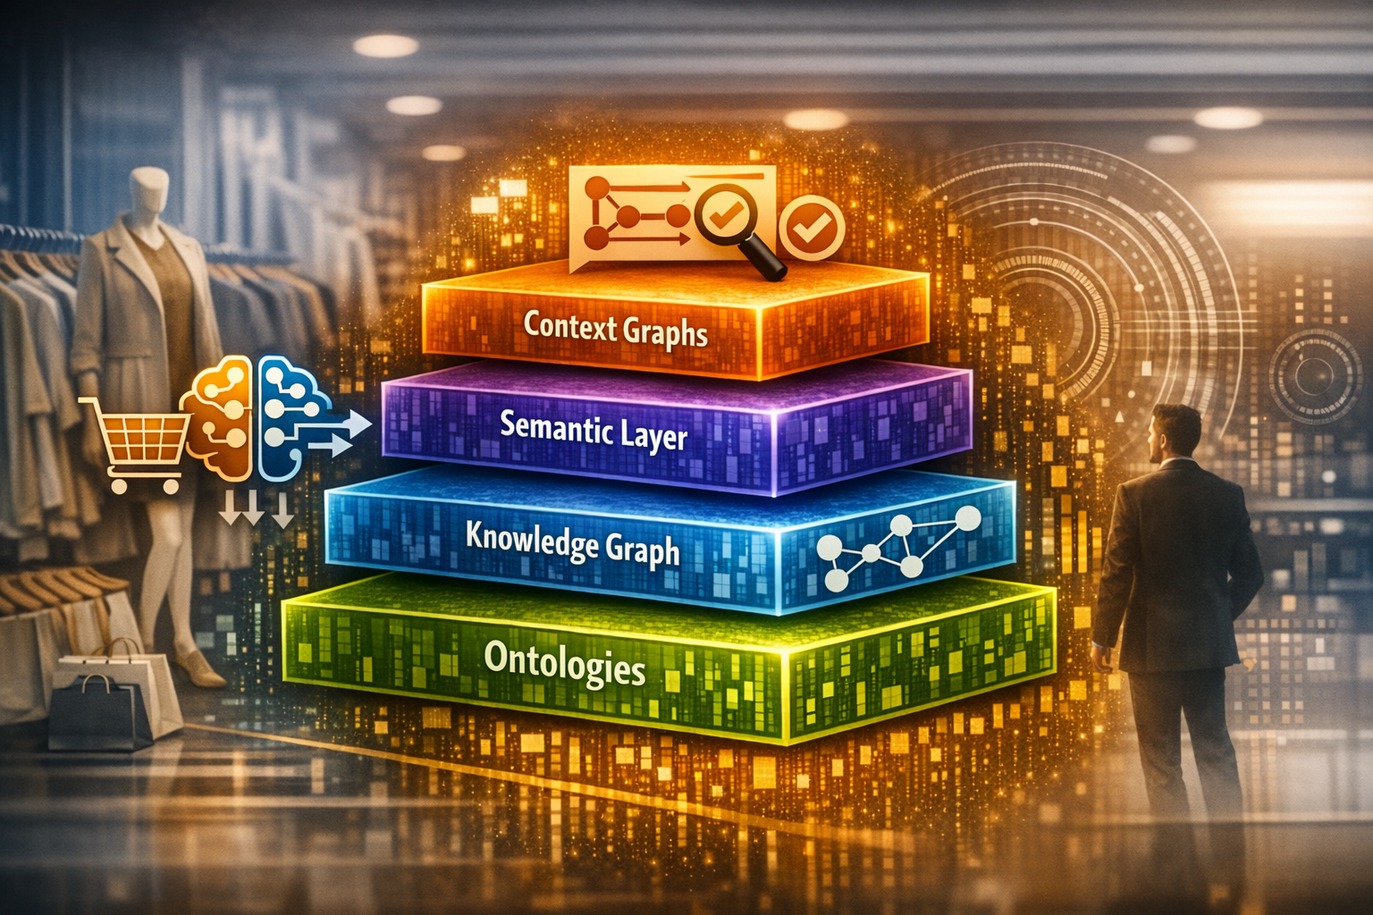
AI Context Stack for Retail — Now More Than Ever
In today’s retail landscape, customer expectations aren’t just rising—they’re shifting in real time. Shoppers move fluidly across channels, expect hyper-personalized experiences, and assume retailers already understand their preferences, context, and intent. Traditional data architectures weren’t built for this.
AI is rewriting the rules, and to truly unlock its value, retailers need more than data and models.
They need context—the missing layer that turns AI from reactive to intelligent.
Recently, I came across a brief (from Atlan) that breaks down the AI Context Stack into four layers: Ontologies, Knowledge Graphs, Semantic Layers, and Context Graphs. These concepts may sound technical, but their impact on retail is deeply practical.
Applying this to a Retail context, here’s how they translate into real competitive advantage for every retailer.

1. Ontologies: The Retail Rulebook
Ontologies define the formal structure of your business—your products, categories, promotions, attributes, relationships, and constraints. Think of them as retail’s updated Dewey Decimal System, ensuring consistency across systems. [<File>AI C...pdf</File> | PDF]
In retail, this means:
- “Color,” “shade,” “tone,” and “finish” all map to a unified definition.
- “Promotion” always means the same thing across POS, CRM, and e-commerce.
- “Order,” “shipment,” and “delivery” relationships remain logically consistent.
A strong ontology is what powers scalable reasoning—like identifying conflicting promotions or understanding if two SKUs are true substitutes.

2. Knowledge Graphs: The Living, Breathing Retail Universe
Once the rules are defined, a Knowledge Graph populates them with real retail data—your customers, products, stores, transactions, and their relationships. [<File>AI C...pdf</File> | PDF]
Imagine having a unified graph that answers:
- “Which products are frequently bought together?”
- “Which customers exhibit similar buying patterns during seasonal peaks?”
- “Which stores consistently outperform on new launches—and why?”
Knowledge graphs allow retailers to finally break the silos between e-commerce, supply chain, loyalty, and in-store operations.

3. Semantic Layers: Translating Complexity Into Business Language
This is the business interface that connects your data to your decision makers. Semantic layers turn technical schema into retail-friendly terms and standardized metrics. [<File>AI C...pdf</File> | PDF]
This solves some of the industry’s biggest headaches:
- Everyone defines “same-store sales” the same way.
- “Customer lifetime value” is not recalculated in 10 different ways across teams.
- Reports and dashboards stop contradicting each other.
In a world where speed matters, semantic consistency is a superpower.

4. Context Graphs: Retail’s Real-Time Intelligence Layer
This is where the magic happens. A Context Graph adds operational metadata—lineage, governance, decisions, temporal changes, and situational relevance—so AI can reason in the moment. [<File>AI C...pdf</File> | PDF]
Context is what makes AI feel personalized and human.
It lets retailers answer:
- “What should we recommend to this customer right now, given their current mission and journey?”
- “Which store needs labor support today based on footfall trends and inventory delays?”
- “Which order is at risk of SLA breach, considering real-time logistics signals?”
Context Graphs shift AI from static answers to dynamic decision-making.

Why This Matters for Retail Leaders
Retailers are not choosing between Ontologies, Knowledge Graphs, Semantic Layers, or Context Graphs.
They’re choosing the right mix—based on what problem they’re trying to solve. [<File>AI C...pdf</File> | PDF]
- Want consistent sales metrics? → You need a semantic layer.
- Want deep customer understanding? → Build a knowledge graph.
- Want AI that reasons like a seasoned merchandiser? → Invest in ontologies.
- Want real-time customer experiences? → Activate context graphs.
As someone who works across business and technology, I see a clear pattern:
Retail transformation stalls not because of lack of data, but because of lack of context.
AI without context is like having a great store without trained staff.
AI with context is like having your best associate on every channel, 24/7.

The Future of Retail AI Is Context-Driven
The greatest retail differentiators ahead won’t be algorithms—they’ll be architectures that let AI understand:
- What something is (Ontology)
- How it connects (Knowledge Graph)
- How we talk about it (Semantic Layer)
- Why it matters right now (Context Graph)
If retailers want AI that truly understands customers, anticipates needs, and enhances operations, embracing the AI Context Stack is not optional. It’s foundational.

